BLAST Analysis Report
Sequence Homology Analysis of Human Proto-Oncogene Tyrosine -Protein Kinase ABL1 (BCR-ABL Target Protein)
Code Alpha Bioinformatics Internship- Task1 Protein Sequence Analysis
(Chronic Myeloid Leukemia -CML)

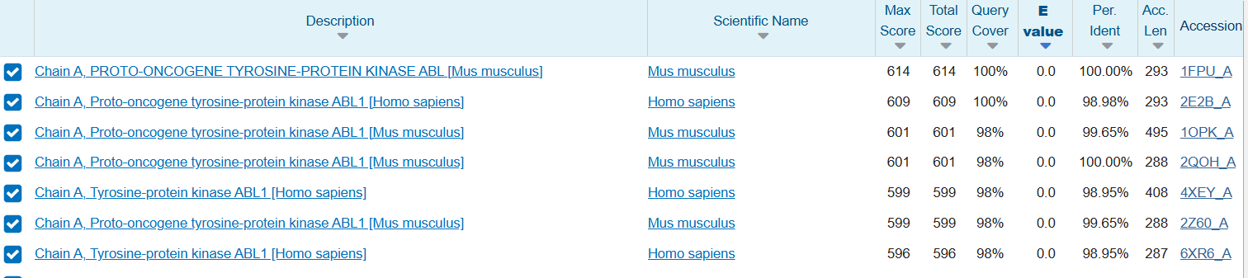
Fig. 1: Protein BLAST (BLASTp) result table showing sequence similarity hits for the query protein (ABL1 kinase domain) across different organisms and PDB entries.
100% Query coverage in the top hit (entire sequence aligns with the identified protein). Very high sequence identity (98.26%–100%); the query sequence is almost identical to known Proto-oncogene tyrosine-protein kinase ABL1 across both human and mouse structures. E-value matches are highly significant (0.0 across all hits), and the alignment can be considered biologically reliable.
Top hit: Represents mouse ABL1 (PDB 1FPU_A), showing 100% identity, 100% coverage. The second-ranked hit, 2E2B_A, represents human ABL1 with 98.98% identity an excellent structural template for human-relevant drug discovery work.
To conclude, BLAST analysis confirms the query protein corresponds with high confidence to ABL1 tyrosine-protein kinase, the catalytic domain responsible for the constitutive kinase activity in the BCR-ABL fusion protein.
Results indicate that the query sequence is highly conserved across mammalian species and belongs to the ABL1 tyrosine kinase family, a key regulator of cell proliferation and survival — and, when fused as BCR-ABL, the direct driver of Chronic Myeloid Leukemia (CML).
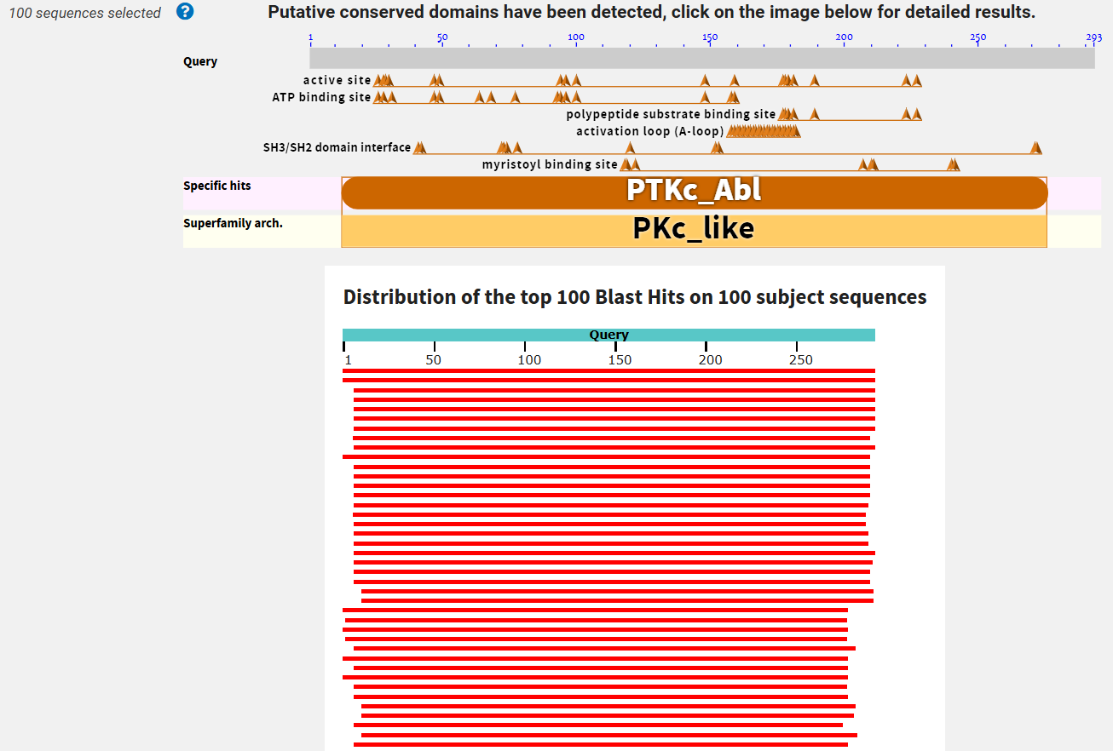
Fig. 2: Conserved domain analysis and BLAST hit distribution for the ABL1 kinase domain protein
Conserved domain architecture
Conserved domain analysis revealed that the query sequence contains the characteristic domain architecture of a protein tyrosine kinase (PTKc_Abl), belonging to the PKc_like superfamily. Several functionally critical sites were identified across the ~293-residue sequence:
Active site residues distributed across the kinase domain, responsible for catalyzing phosphate transfer
ATP binding site residues located primarily in the N-terminal lobe, essential for binding ATP (the phosphate donor for kinase activity)
Polypeptide substrate binding site, were target proteins dock for phosphorylation
Activation loop (A-loop), a critical regulatory segment (~residues 145–170) that controls the kinase's active/inactive conformational switch
SH3/SH2 domain interface residues, which normally interact with the SH3-SH2 regulatory domains to keep the kinase in an autoinhibited (OFF) state
Myristoyl binding site, involved in another autoinhibitory mechanism where a myristoylated N-terminus folds back to lock the kinase inactive
Presence of these domains confirms that the query sequence possesses the typical structural organization of a functional ABL1 tyrosine kinase. Specific hit: PTKc_Abl; superfamily architecture: PKc_like.
Graphical analysis
Blast hit distribution of the top 100 hits shows continuous, full-length red bars aligning across nearly the entire query sequence (residues 1–293), indicating strong evolutionary conservation and supporting the functional annotation of the sequence as ABL1 kinase.
Biological relevance
Critical for ABL1's dual regulatory mechanism (SH3/SH2 autoinhibition + myristoyl switch) and its catalytic kinase function.
Red bars — BLAST alignment hits, representing top 100 BLAST hits
Continuous red bars indicate full-length sequence conservation; no truncations or missing domains, confirming high evolutionary conservation of ABL1 across species and structures.

